**CN Practical 1**

**Q.1 How are network categories explain in brief?**

Computer Networks can be categorized by range, functional relationship, network topology and specialized function.

* **By range**
* personal area network (PAN)
* local area network (LAN)
* metropolitan area network (MAN)
* wide area network (WAN)
* wireless LAN
* wireless PAN
* **By functional relationship**
* client-server
* multitier architecture
* Peer-to-peer
* **By network topology**
* bus topology
* star topology
* ring topology
* mesh topology
* **By specialized function**
* Storage area networks
* Server farms
* Process control networks
* Value added network
* SOHO network
* Wireless community network

**Q.2 What is difference between switch, hub, router network device?**

|  |  |  |
| --- | --- | --- |
| **hub** | **switch** | **router** |
| A Hub works on the basis of broadcasting. | Switch works on the basis of MAC address. | A router works on the basis of IP address. |
| A Hub is a multiport repeater in which a signal introduced at the input of any port appears at the output of the all available ports. | A Switch is a telecommunication device which receives a message from any device connected to it and then transmits the message only to the device for which the message is intended. | A router reads the header of incoming packet and forward it to the port for which it is intended there by determines the route. It can also perform filtering and encapsulation. |
| A Hub does not have storage. | A Switch has storage. | A Router has storage. |
| A Hub can’t store any information about device which is connected to hub | A Switch is store MAC address and port number of each and every device. | A Router is store IP address of each and every device. |
| Hub is not an intelligent device that may include amplifier on repeater. | A Switch is an intelligent device as it passes on the message to the selective device by inspecting the address. | A route is more sophisticated and intelligent device as it can read IP address and direct the packets to another network with specified IP address. Moreover routers can build address tables that helps in routing decisions. |
| Not Secure | Secure | Secure |
| Best use when we need broadcast message. | Best use when we need pass data in network from one device to another device. | Best use when we need pass data from one network device to another network device. |
| More traffic compares to switch, router. | Less traffic compare to hub | Less traffic compare to hub |
| Unwanted copy generated to broadcasts message. | Pass message from source to destination without generating unwanted copy of message. | Pass message from source to destination without generating unwanted copy of message. |
| A Hub can’t identify the destination device because it can’t store any information about devices. | A Switch easily identifies the destination device because it can store MAC Address and port number of each and every device. | A Switch easily identifies the destination device because it can store IP Address of each and every device. |

**Q.3 Explain Bus, Star, Ring, Mash topology in brief. How message are transfer between devices also write advantage and disadvantage in brief?**

**1: Bus Topology**

In bus topology each computer and network device is connected to a single cable or [backbone](https://www.computerhope.com/jargon/b/backbone.htm).

**How it Works.**

Attached nodes can send data in both directions depending on where they are on the bus. Bear in mind, however, that data can only be sent in one direction only at a time. Each node has an individual address which is instrumental in data transmission processes. When a message is sent out from one computer, it gets onto the backbone. This means that the message actually reaches all the nodes. It is now upon the intended recipient node to identify its address on the sent message. If a node sees that the message’s address does not match its then it disregards the message. If it matches its address it then proceeds to process the message.

Advantages:

* Most Suited For Small Network.
* It requires less cable length than other topology.
* It is easy to connect or remove devices in this network without affecting any other device.
* It is easy to understand topology.
* Easy to expand by joining the two cables together.
* Low-cost Cable

Disadvantages:

* It can be difficult to identify the problems if the whole network goes down.
* It can be hard to troubleshoot individual device issues.
* Bus topology is not great for large networks.
* Terminators are required for both ends of the main cable.
* Additional devices slow the network down.
* If a main cable is damaged, the network fails or splits into two.

**2: Star Topology**

Every [node](https://www.computerhope.com/jargon/n/node.htm) connects to a central network device in this configuration, like a [hub](https://www.computerhope.com/jargon/h/hub.htm), [switch](https://www.computerhope.com/jargon/s/switch.htm), or computer. The central network device acts as a [server](https://www.computerhope.com/jargon/s/server.htm), and the peripheral devices act as [clients](https://www.computerhope.com/jargon/c/client.htm).

**How it Works.**

* If the hub is used as a central part of the network then it receives a message from any computer and then broadcast the message to all the computers. The message contains the mac address of the computer to which the data should be sent. So when the hub broadcast the message then if the mac address matches a computer in the network then that computer will receive the data.
* If the switch is used as a central device then in the case of switch it stores all the mac addresses of the computers connected. So switch not broadcast the message to all the computers as it already knows mac addresses of computers connected to the switch. Data is sent to the destination computer if mac address of that computer matches from the switch.

Advantages:

* Centralized management of the network through the use of the central computer, hub, or switch.
* Easy to add another computer to the network.
* If one computer on the network fails, the rest of the network continues to function normally.

Disadvantages:

* It may have a higher cost to implement, especially when using a switch or router as the central network device.
* The central network device determines the performance and number of nodes the network can handle.
* If the central computer, hub, or switch fails, the entire network goes down, and all computers are disconnected from the network.

**3: Ring Topology**

* A ring topology is a [network](https://www.computerhope.com/jargon/n/network.htm) configuration where device connections create a circular [data](https://www.computerhope.com/jargon/d/data.htm) path. Each networked device is connected to previous node as well as next node.
* In a ring network, [packets](https://www.computerhope.com/jargon/p/packet.htm) of data travel from one device to the next until they reach their destination.
* Packets of data travel only one direction is called **unidirectional ring**.
* Packets of data travel both directions is called **bidirectional ring**.

**How it Works.**

When the data is needed to reach at a specific node, then the data packet goes through each of the intermediate nodes in the ring topology network and when it reaches the destination node, it gets copied at that system.

**Token**

* In a token ring network, a single special packet called a token is passed around the token network, and it waits until the token is available to transmit data to a computer.
* In short, the token is passed across the ring, the computer modifies the token, adds the electronic address and data, and sends it around the ring, and each computer in the order receives the token and passes the information to the next computer.
* The process goes on, until when the token does not return to its originator and the computer receives a return message as a confirmation that indicates it was sent.

There are two types of token release techniques:

**Early token release:** releases the token just after transmitting the data.

**Delay token release:** releases the token after the acknowledgment is received from the receiver.

Advantages:

* It is easy to install ring topology because it needs fewer connections. That means the cost of installation is also less because of its short cable length requirement.
* It is easy to manage, whenever you add or remove the device from the ring topology. Because in this only two neighboring nodes are required to change.
* Ring topology does not require any kind of central device or a centralized control system.
* In the ring topology, only one cable connects each node to its neighboring nodes, so no wiring closest space required.
* As data travels in one direction only around the ring, it is suitable for using optical fibers, so network speed is quite good or there is a possibility of having a high-speed transmission.

Disadvantages:

* If one of the nodes gets fails to transmit the data through itself, the entire network gets failed. In short, node failure causes network failure, and the network can’t be useful until the defective node has been removed/replaced from the ring.
* The addition of a new node or removing an old device to a ring network then there is a possibility that you need to reconfigure the whole system.
* If you have a large network then the diagnosis of a faulty node is difficult and you may require to check many points in the network to find the faulty node.

**4: Mesh Topology**

* A mesh topology is a network setup where each computer and network device is interconnected with one another.
* There are multiple paths from one computer to another computer.
* It does not contain the switch, hub or any central computer which acts as a central point of communication.

Advantages:

* It is robust.
* The fault is diagnosed easily. Data is reliable because data is transferred among the devices through dedicated channels or links.
* Provides security and privacy.

Disadvantages:

* Installation and configuration are difficult.
* The cost of cables is high as bulk wiring is required, hence suitable for less number of devices.
* The cost of maintenance is high.

**Q.4 What is an IP address? Assign an IP address to three PCs connected to the same network. Create another network to show how communications will be performed between two PCs on different networks using router.**

**What is IP address?**

An Internet Protocol address (IP address) is a numerical label assigned to each device connected to a computer network that uses the Internet Protocol for communication.

IP address is provided by **ISP (Internet Service Provider).**

**Assign IP address in 3 pc connected in same Network.**

To do this we need Cisco Packet Tracer software.

Just download it from website and install it.

Open It.

**Step 1):** Simply add 1 Network Device Switch and 3 PC in Cisco Packet Tracer.

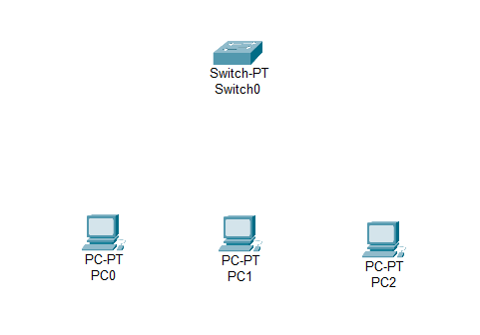

**Step 2):** Connect them via Copper Straight cable

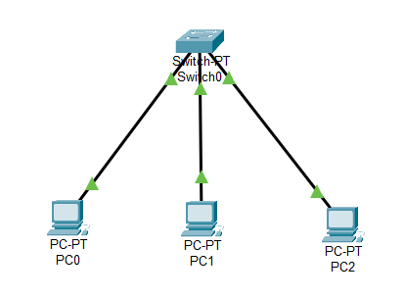

**Step 3):** Assign IP addresses of each pc as you want. I am assigned IP like 10.10.1.0 series.

How to assign

1: Click on pc in

2: Go to Desktop Tab

3: Go to IP Configuration

4: Add IP in IP Address Textbox

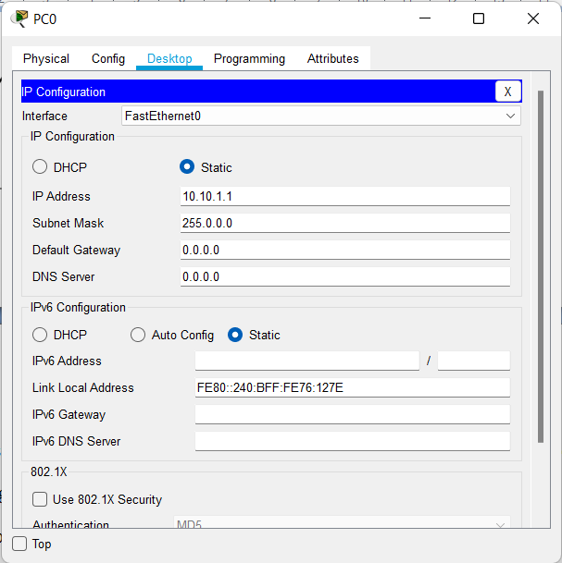

**Create another network to show how communications will be performed between two PCs on different networks using router devices.**

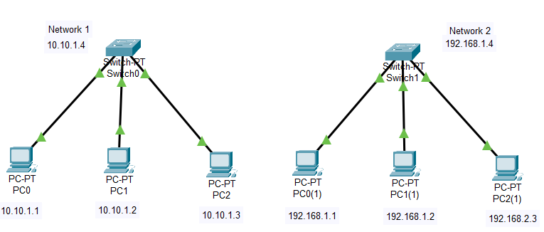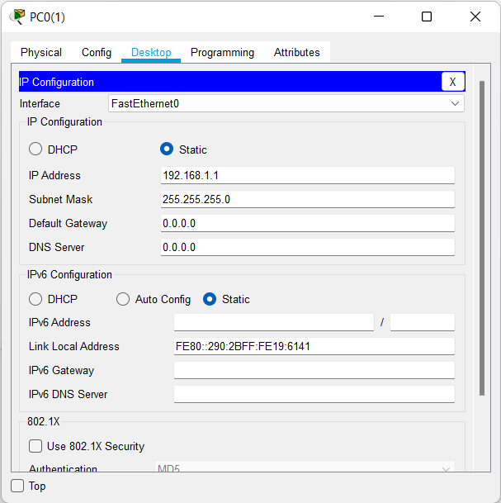**Step 1):** Create another network as shown above. However, in the second network, assign a different IP address series. I am using 192.168.1.0 series for second network.

**Step 2):** Take one network device router.

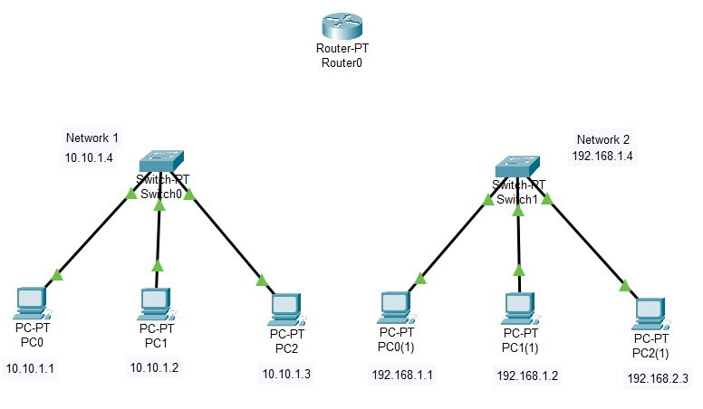

**Step 3):** Connect both Switches with Router via Copper Straight cable.

**Step 4):** Configer Router to connect two different networks.

1: Click on router.

2: Go to Config Tab.

3: On the left side select which port where switch is connected to.

4: Assign the switch's IP address. One by one and ‘**on**’ the port status after assigning the IP.

1 Network switch IP address is: 10.10.1.4

2 Network switch IP address is: 192.168.1.4

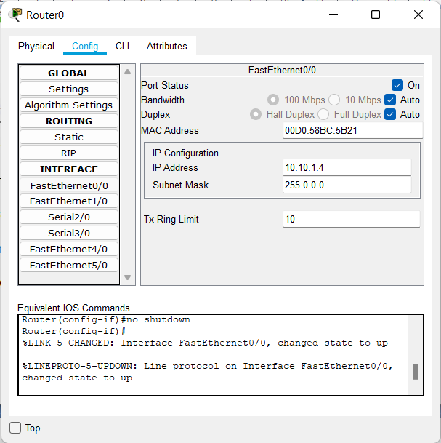 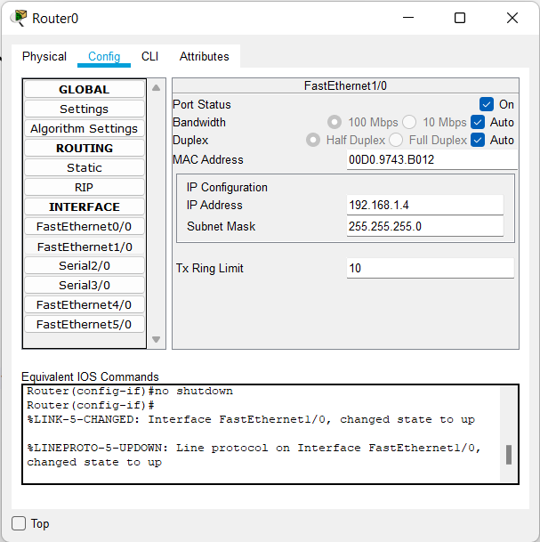

**Step 5):** Add the default gateway to each and every PC that is available on both networks.

Default gateway is the IP Address of switch.

First network Default gateway is 10.10.1.4

Second network Default gateway is 192.168.1.4

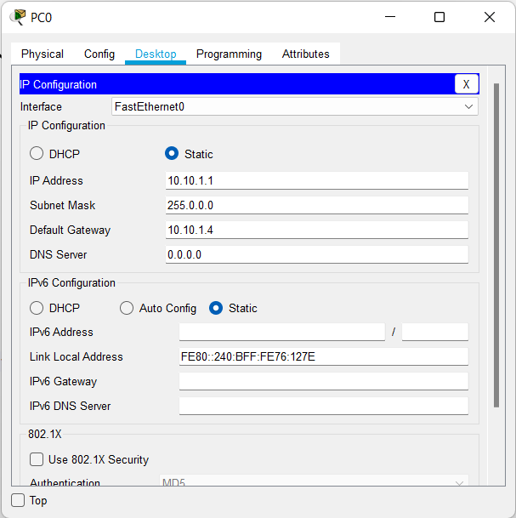 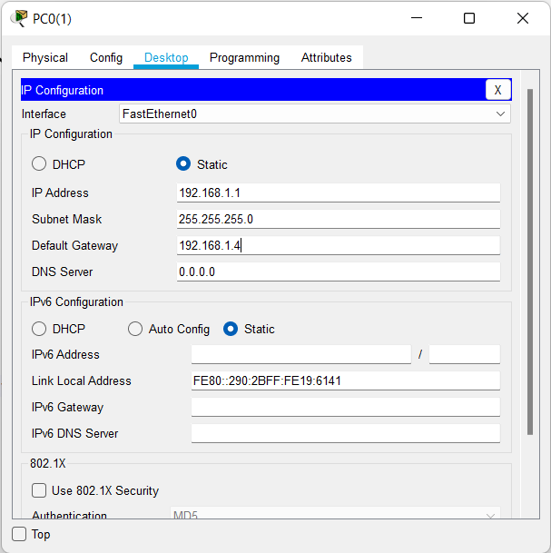

**Example:** Assume PC 1 of network 1 sends a message to PC 2 of network 2. What happens next?

Step 1): Sender PC of network 1 is pass message to switch.

Step 2): A switch of first network receive message and pass message to router.

Step 3): The router receives the message and forwards it to the second network switch.

Step 4): A switch on a second network receives messages from the router and passes them to a particular destination PC.

Step 5): A destination PC receives a message from the switch and passes a confirmation message to the switch of the second network.

Step 6): A switch on a second network receives a confirmation message from the destination PC and passes this message to the router.

Step 7): The router receives a confirmation message from the switch of the second network and passes this confirmation message to the first network switch.

Step 8): A switch on the first network receives the confirmation message from the router and passes the confirmation message to the sender PC.

Step 9): The confirmation message is received by the sender PC.

**Q.5 What kind of topology is used to minimize traffic problem?**

Under the mesh topology, every pair of nodes has a dedicated line or a dedicated channel. Since every pair of node has a dedicated link, so there is no traffic in this case. Hence, traffic issues or problem can be minimized using the mesh topology.